DigestSim: A Web-Based Tool for Restriction Enzyme Analysis and DNA Digest Simulator

Vedangi Priyadarshini
Introduction
Restriction enzymes or restriction endonucleases, are proteins that recognize specific short nucleotide sequences and cleave at or near those sites. These recognition sequences are typically palindromic, meaning they read the same on both strands in 5' to 3' direction. In nature, these enzymes act as immune defense mechanism protecting bacterial cells from invading foreign DNA. In the laboratory, they have become tools for DNA cloning, genome mapping, and recombinant DNA construction. Depending on where and how they cut, restriction enzymes produce sticky or blund ends. Sticky ends are short single-stranded overhangs that facilitate ligation with complementary fragments. Blunt ends are straight double-stranded cuts leaving no overhangs. Predicting where enzymes will cut a given sequence is a critical step in experimental design, yet doing so manually is tedious and error-prone. For my final project, I propose to build a web-based restriction enzyme analysis and digest simulation tool called DigestSim that will allow users to input a DNA sequence to identify all potential cut sites by the selected enzymes and visualize the resulting fragment sizes entirely.

Tool Functionality
DigestSim will be designed to provide users with an interactive web-based interface for planning and validating restriction enzyme digestion experiments. The tool offers a history browsing feature and a visual output display accessible through a graphical user interface. The user begin by pasting/typing a DNA sequence into a text area field and optionally providing a name for their submission. The tool offers two modes of analysis - first, the user selects one or more specific enzymes from a dropdown menu to simulate a single or double enzyme digest; second, the tool automatically scans the entire enzyme database and reports every enzyme with a recognition sequence present in the submitted DNA. Results are displayed in a table showing enzyme name, recognition sequence, cut positions, and resulting fragment sizes, with a visual cut map that marks cut sites along a linear representation of the sequence. All submissions and their results are stored in the database and accessible through a history page, where users can browse and revisit past analyses.

Technical Implementation
The user interface will be built using HTML5, styled through an external CSS stylesheet, with JavaScript and jQuery loaded from external script files to handle client-side interactions including dropdown filtering, mode toggling, input validation, and visual cut map rendering. Server-side logic will be implemented in Python with separate CGI scripts for sequence submission and history retrieval. Database connectivity will be handled using the mysql.connector Python module to establish connections, execute parameterized SQL queries, and retrieve results for enzyme lookups, submission inserts, and history retrieval from the MySQL database.

Database Schema
The application will utilize two MySQL database tables. The first table enzyme_db will serve as the reference table for all restriction enzyme information sourced from REBASE, containing fields for enzyme_id as primary key, enzyme_name, recognition_sequence, cut_positon, overhang_type indicating whether it produces a 5' sticky end, 3' sticky end, or blunt end, enzyme_type, and commercial_supplier. This schema is justified by the need to store all relevant enzyme attributes required for both digest simulation and informational display returned to the user.

The second table submissions stores a record of every analysis performed through the application, containing fields for submission_id as the primary key, submission_name, dna_sequence, enzyme_ids_used, analysis_mode indicating whether the user selected specific enzymes or performed a full database scan, cut_postions, fragment_sizes, and submission_date as a timestamp. This table is justified to persist user submission history for retrieval and display on the history page, enabling users to revisit and compare past analyses over time.

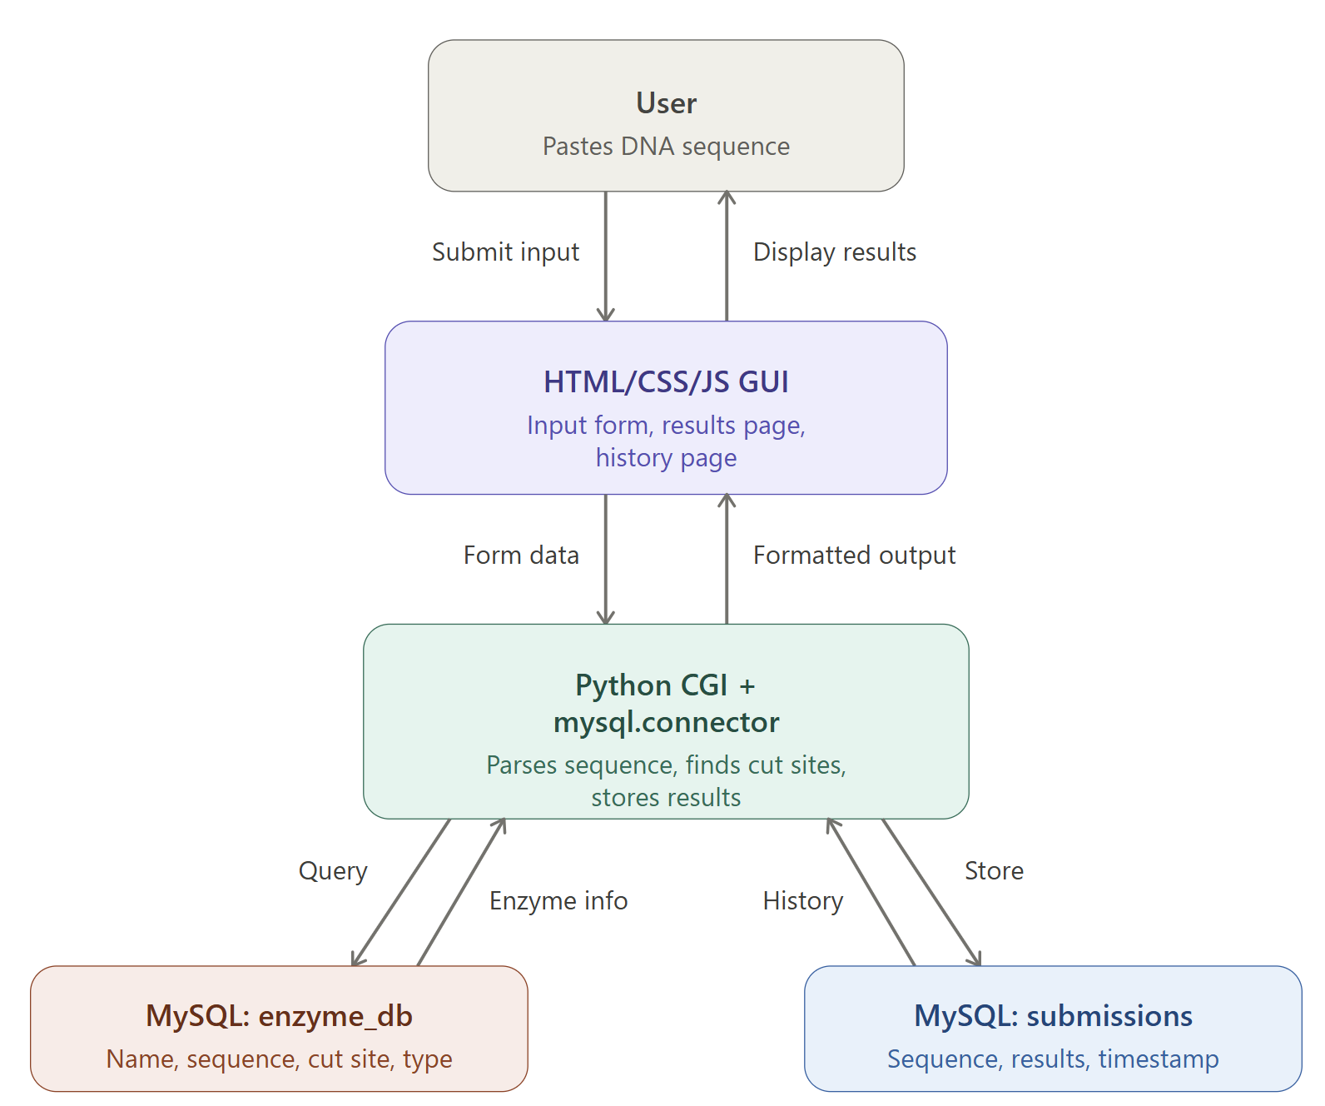
Figure 1: Software components and their interactions

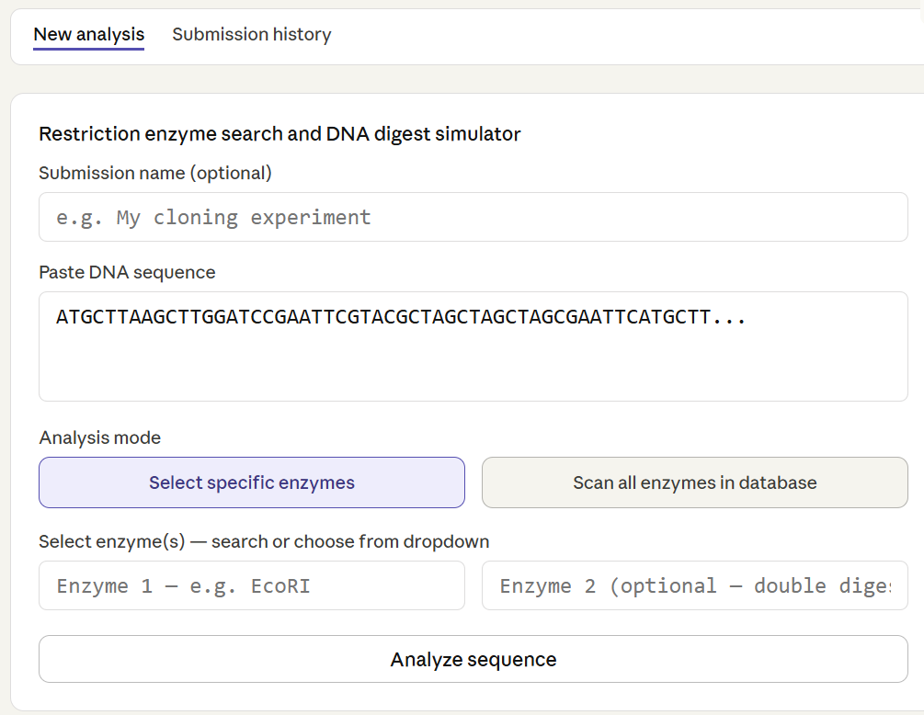
Figure 2: Input Page Idea

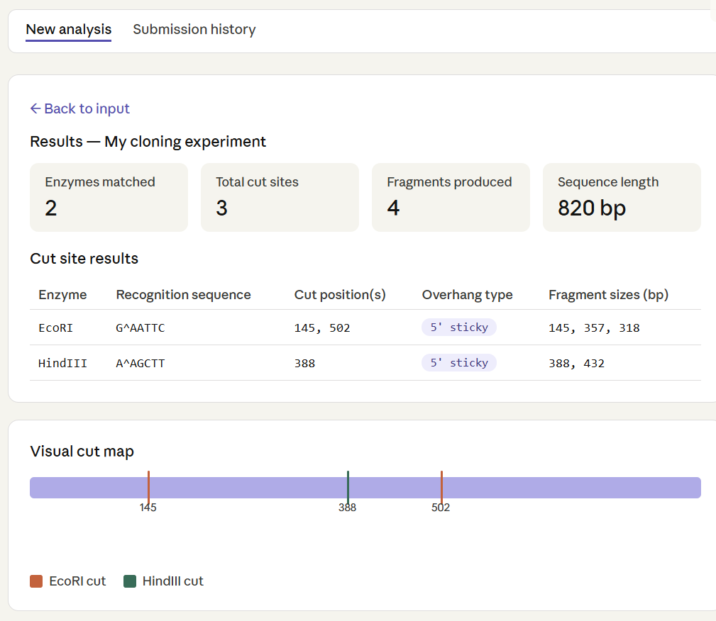
Figure 3: Results Page Idea

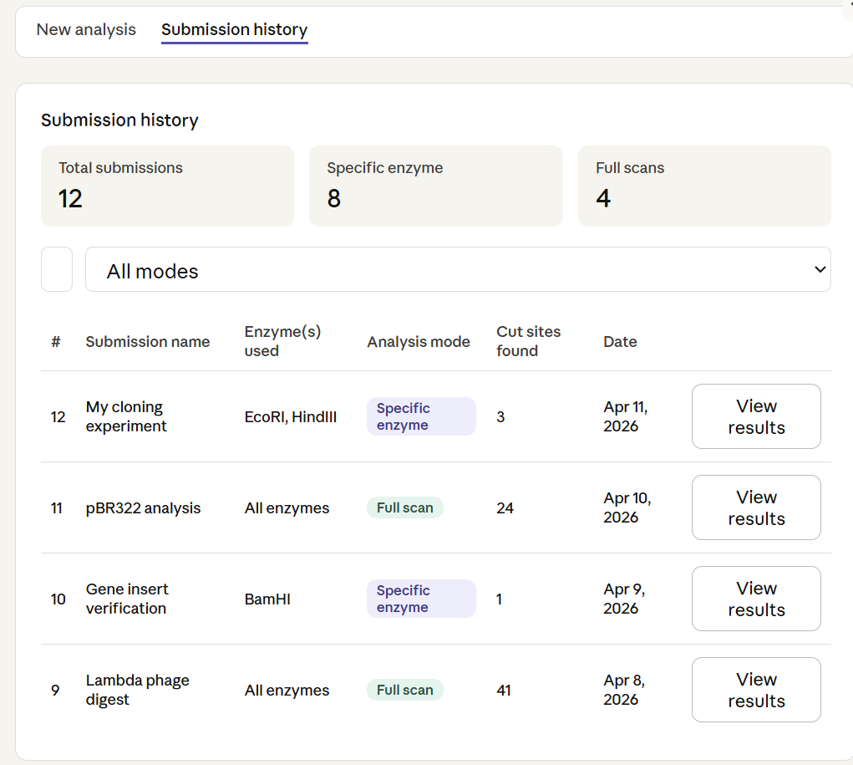
Figure 4: Submission History Page Idea

